**8-BIT ADDITION**  
  
  
**EXP NO: 1**  
  
 **AIM:**  
To write an assembly language program to implement 8-bit addition using 8085  
processor.

**APPARATUS REQUIRED:**

* GNUSIM8085

**ALGORITHM:**  
  
  
1)      Start  
the program by loading the first data into the accumulator.  
2)      Move  
the data to a register.  
3)      Get  
the second data and load it into the accumulator.  
4)      Add  
the two register contents.  
5)      Check  
for carry.  
6)      Store  
the value of sum and carry in the memory location.  
7)      Halt.

**PROGRAM:**  
  
LDA 8500  
MOV B, A  
LDA 8501  
ADD B  
STA 8502  
RST 1

**INPUT:**

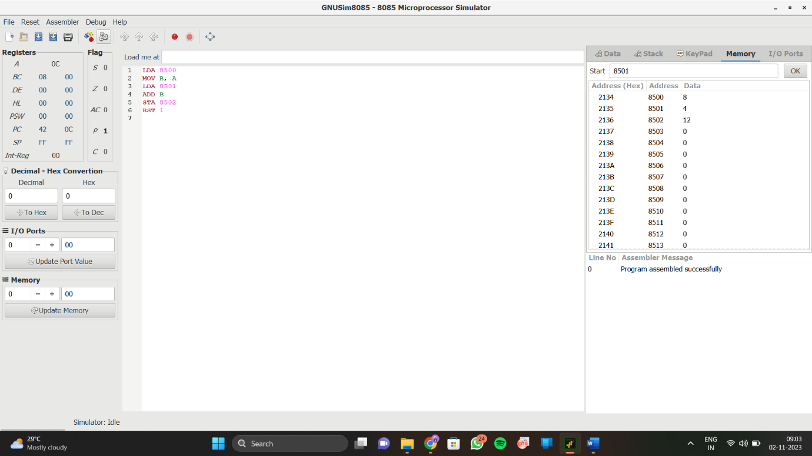

**OUTPUT:**  
  
  
   
  
  
   
  
  
   
  
  
   
  
  
  
  
  
  
  
  
  
  
  
  
  
**RESULT:**

Thus the program was executed successfully  
using 8085 processor simulator.